|  |  |  |  |  |  |  |  |  |  |  |  |  |  |
| --- | --- | --- | --- | --- | --- | --- | --- | --- | --- | --- | --- | --- | --- |
| |  | | --- | | Document Legend |   C:\Users\P00341017\Documents\JA FileZ\Key Information\Misc Office\Jordan's Document Command Legend.png   * O The Structure / Syntax line displays the structure of the command and labels the parts. * O Example Command lines are verbatim or previously used command inputs that can actually be used or copied. * O Input / Output lines contain real images of the command in use, often showing context. * Purple highlights denote commands. * Red highlights denote user supplied or contextually dictated values. * Blue highlights denote options or operands that change how commands function. * Some commonly used abbreviations:  |  |  |  |  |  |  | | --- | --- | --- | --- | --- | --- | | Fn | Ft | Fm | Vdev | Mdisk | Mode | | Filename | Filetype | Filemode | Virtual Device Address | Minidisk | Disk Label, Read/write permissions | |

1. Establish downtime for Applications that run on the Source System for upgrading. Provide detailed information to the respective teams for awareness and accurate approvals. Confirm time frame **multiple** times.
   1. Specifically address at what time *other parties are to begin bringing systems down in relation to downtimes. For example applications on a Linux guest, speak with the party responsible for bringing these applications down directly to specify at what exact time they should begin bringing these things down.
   2. Establish how progress and problems will be communicated to the relevant parties.
   3. Communicate what steps will be taken should issues arise.
   4. Plan a backup timeframe for a second attempt, or repair/revert procedures.
2. Fill Worksheet(s) with relevant guest machine information to act as progressive checklists/logs of actions taken, Swap Procedure will cover the steps after the Server Backup Log worksheet’s backups/shell tests are done.
3. Shutdown virtual machine guests.  
   Signal command user  
   Signal shutdown mi99la40  
   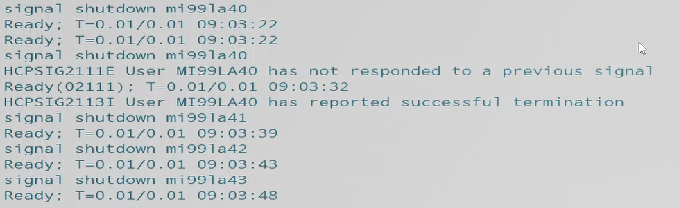
   1. Submit a Query Name to verify all guests are shutdown  
      Query Name  
      q n  
      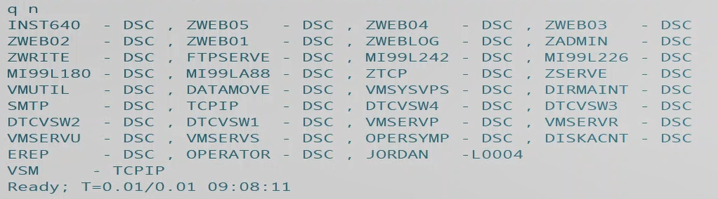
4. Logon by each guest and perform backups (using premade scripts, in accordance with the <worksheets> filled out previously. Special attention to be paid to **which** scripts to use. This will be decided by the vdev addresses for backup MDISKS.)
   1. Use Copy_STD as relevant. (Consult your Worksheet!)  
      copy_std  
      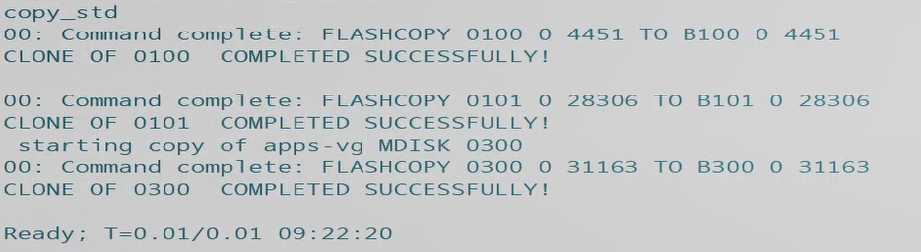
   2. Use Copy_B01 as relevant.  
      copy_b01
   3. Use Copy_B03 as relevant.  
      copy_b03
   4. Use Copyos as relevant.  
      copyos  
      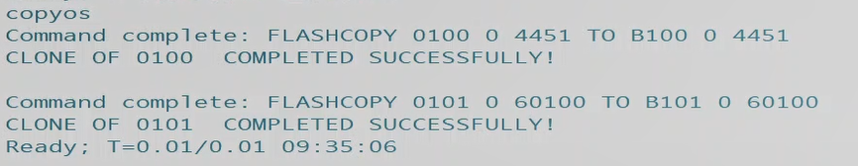
      1. Note any error given as messages will be given if devices are unavailable at logon or the backup scripts are not able to run due to DASD or MDISK being unavailable.  
         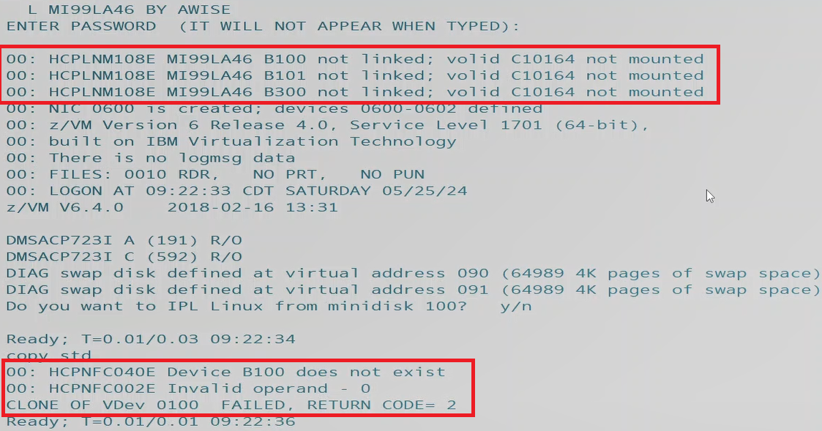
      2. Use direct entries as cross references for locating the address of missing DASD or MDISKS. See below examples of MDISK statements.  
         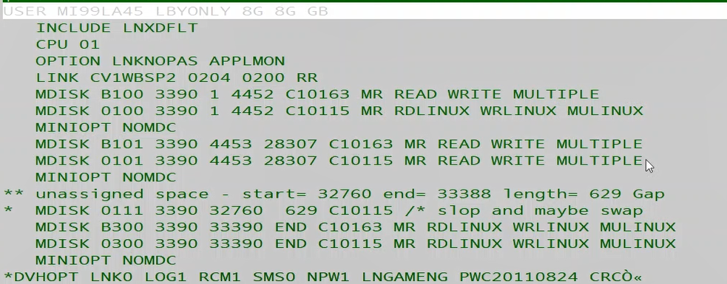
      3. If errors are given for missing DASD for copying – submit a Query DASD to identify missing DASD containing relevant MDISKs.  
         Query operand volid  
         Q dasd c10164  
         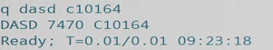
      4. Submit Vary Online commands before attempting to attach devices (just in case for the most part, pre-emptive.)  
         vary operand vdev  
         vary online 7470-747f  
         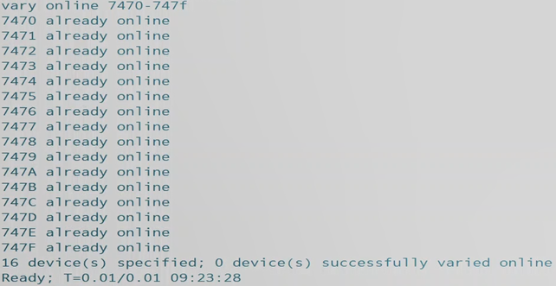
      5. Attach any missing DASD for the backup scripts to function correctly and the guests/system to have access.  
         attach vdev operand  
         att 7470-747f to system  
         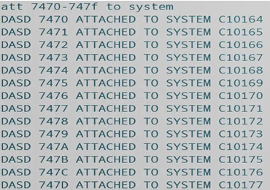
5. Log onto the Target system (being hosted second level on a placeholder IP) and change the file name of the edited-in-waiting System Config file containing the tailored/desired values and parameters of the finished system. *Inspect and confirm all tailored lines are correct, VERY Important. Run a CPSYNTAX as well to be safe.
   1. Use VMLINK to establish a connection to pmaint cf0.  
      vmlink user mdisk (option  
      vmlink pmaint cf0 (write  
      
   2. Use filelist to view the files on the now linked pmaint cf0 mdisk.  
      Filelist filename filetype filemode  
      filel * * z  
      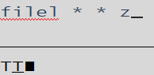
   3. Use VMLINK to establish access to the Maint 193 MDISK to utilize CPSYNTAX.  
      VMLINK user mdisk (option  
      VMLINK maint 193  
      
   4. Use CPSYNTAX to verify system config replacement file’s integrity.  
      CPSYNTAX filename filetype filemode  
      CPSYNTAX system confedit h  
      
   5. Rename or create a duplicate with a new name and discard the original system config.  
      Rename filename filetype filemode newFN newFT newFM (options  
      rename system config z system cnfgold z  
      
      1. Alternatively the user may use copyfile and discard the original, keeping the new copy with the new name.
6. Change the IP Address within PROFILE TCPIP to the Source System’s IP by VMLinking to the Target System’s TCPMAINT 198 MDISK.  
   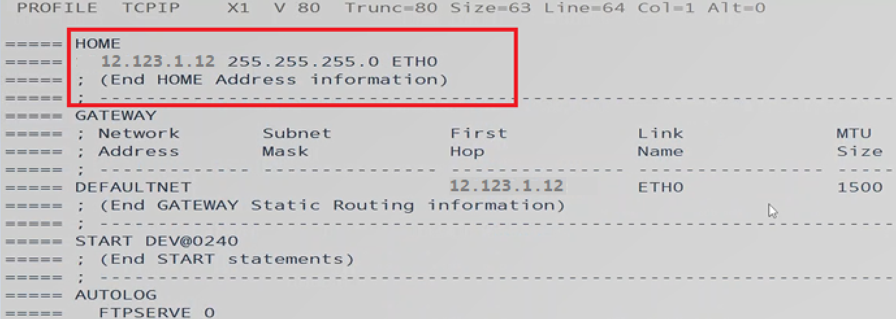
   1. Use VMLINK to access Profile TCPIP on TCPMAINT 198 MDISK.  
      VMLINK user mdisk (options  
      vmlink tcpmaint 198 (write  
      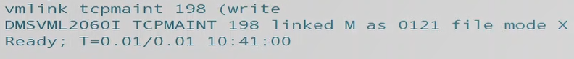
   2. List the files on TCPMAINT with Filelist (or open directly via xedit), and open the file for editing by placing an x in the left-hand command line margin once listed.  
      Filelist filename filetype filemode  
      filel * * x  
      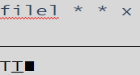
   3. Save and submit changes with the File command on xedit’s command line.  
      File  
      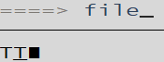
7. Log onto the HMC and bring down the Source System with an Integrated 3270 Terminal, freeing up the 1st Level and IP.  
   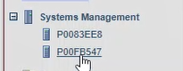  
   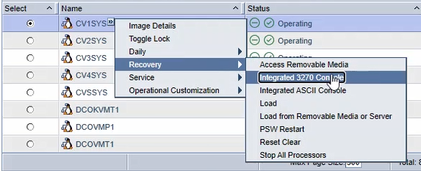  
   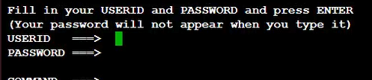
   1. Shutdown the Source System with a privileged user.Shutdown operand systemname operand  
      Shutdown System CV1RES  
      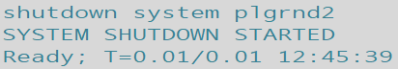
      1. The terminal will either disconnect after 10-30 seconds (try pressing <Enter> to prompt it into showing you’ve been disconnected,) or you’ll be placed in the lower environment and given a message saying the shutdown was successful.
   2. Confirm that the LPAR shows as Deactivated from the HMC view.  
      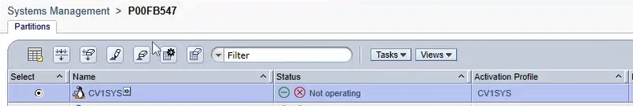
8. Bring up the Target System by specifying the “Load address” accessing the dropdown menu for the relevant system Recovery>Load: enter address.
   1. LPAR > Recovery > Load  
      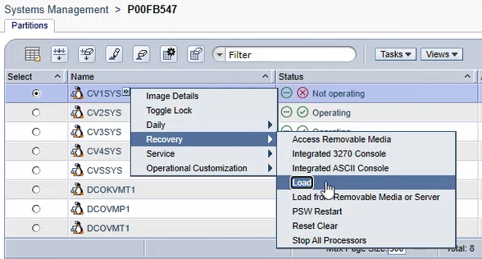
   2. Set the new Load address for the RES volume of the Target Upgraded System.  
      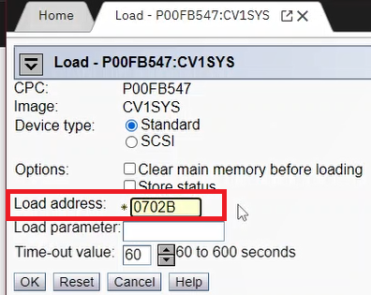
   3. Select. ‘Yes’ for Load Task Confirmation  
      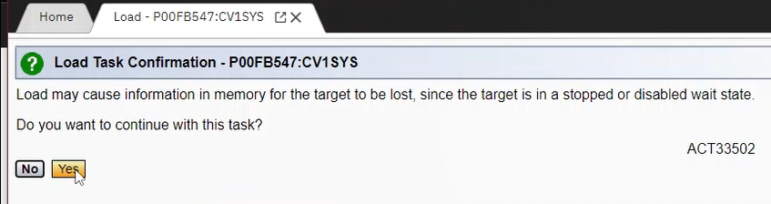
   4. **<CLICK>** the, ‘Yes’ confirmation for Disruptive Task Confirmation after inputting user password.  
      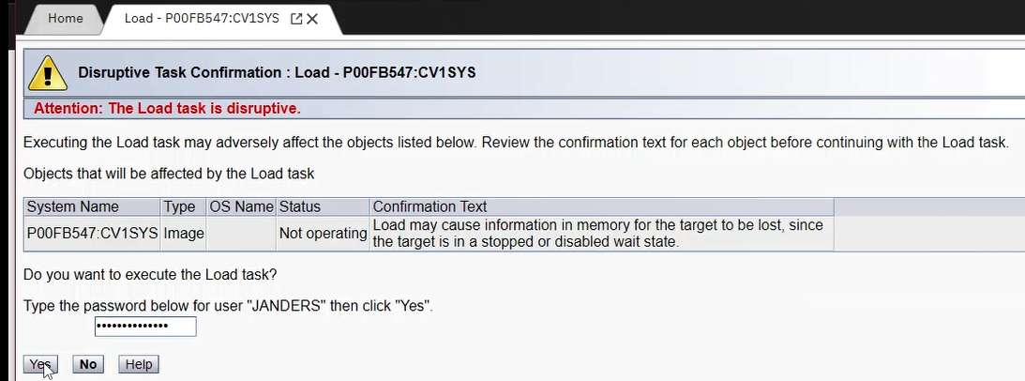
   5. Wait patiently for the Load Progress to finish.  
      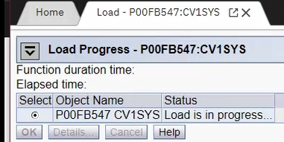
   6. Select, ‘OK’ for Load Progress after Load completes.  
      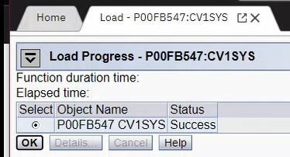
9. Log onto each Linux Guest with a privileged user with Logon By and submit, ‘Y’ for yes to IPL Linux from Minidisk. Wait for it to auto-select the correct following option (0, 1, and 2.)
   1. Logon user By user  
      L Mi99LA42 BY AWISE  
      
      1. Pay close attention to the output and progress of setup, configuration and the upcoming file system check.
   2. Submit, “Y” for Yes to IPLing Linux from Minidisk 100.  
      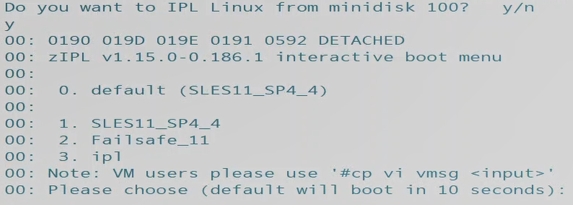
   3. Patiently wait for first time setup and file system checks to succeed and finish. This will take some time.  
      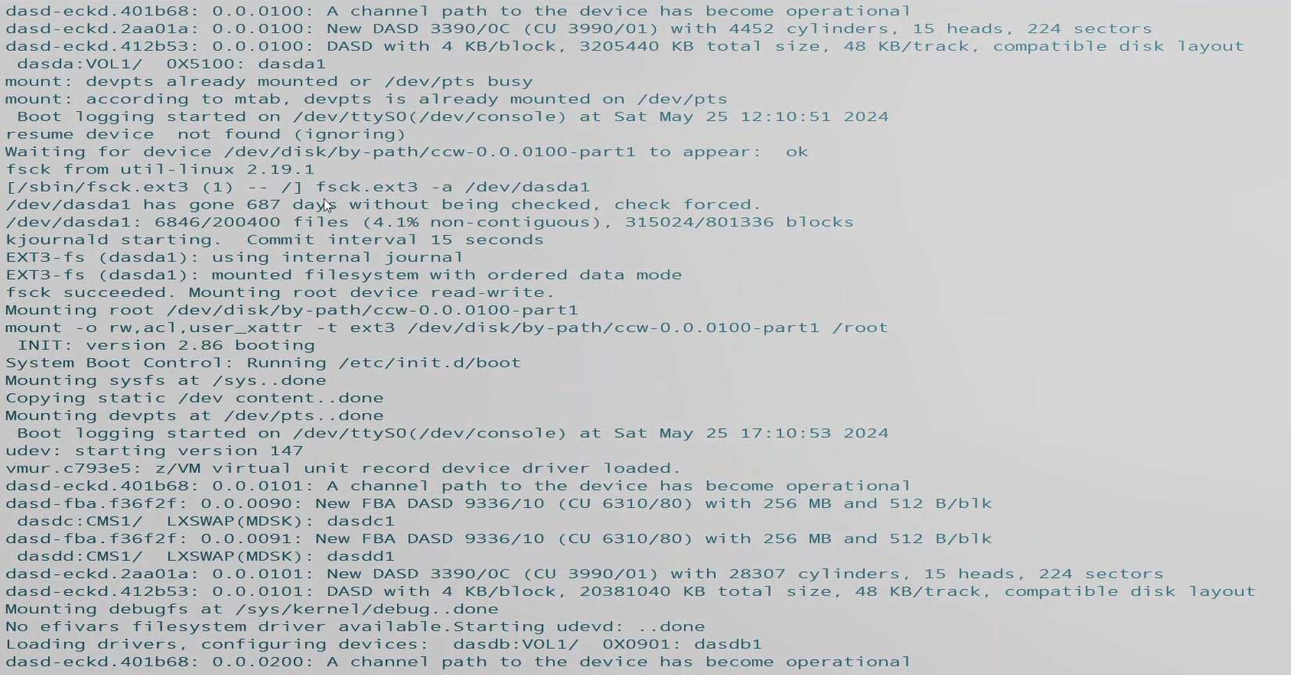
      1. There will be a great deal of screens like above and below – keep watch for suspicious output, nastygrams and error messages.  
         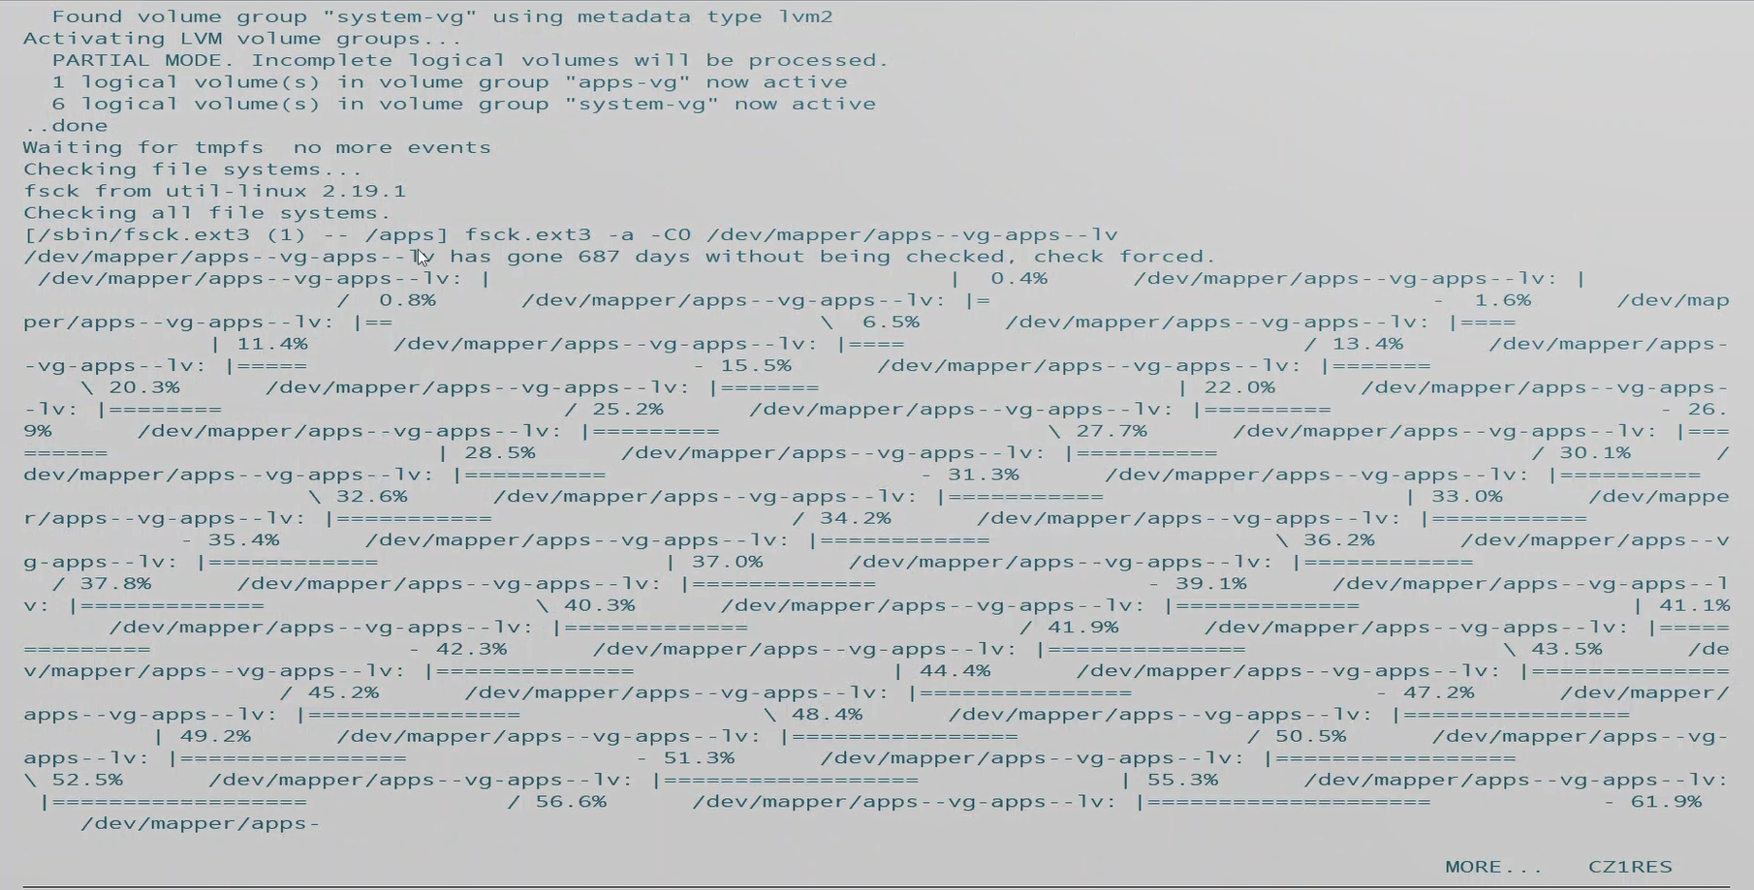
      2. The final output comprising the success of, ‘First Boot’ is the login credential request after checks succeed:  
         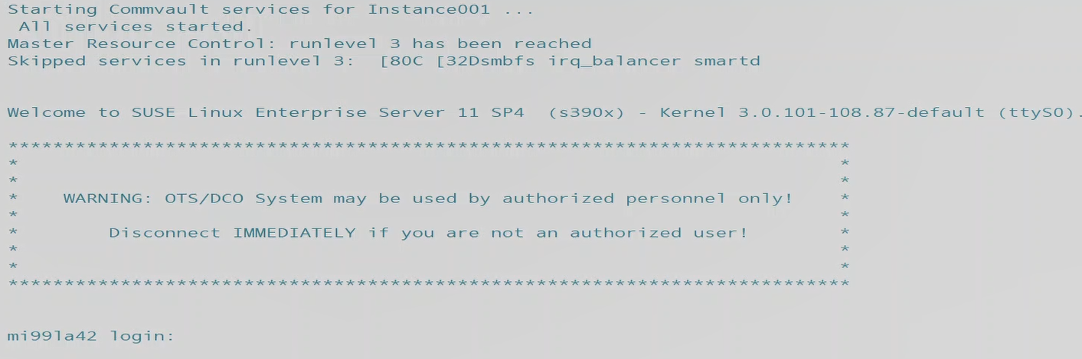
   4. Submit #CP Disconnect commands for the virtual machine guests after verifying it is possible to Login and First Boot succeeded.  
      #CP Command  
      #cp disc  
      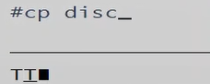
10. Submit Signal shutdowns to the virtual machine guests to bring them down for xautolog to bring them back online disconnected.
    1. Signal command user option  
       Signal shutdown mi99laxx within 30  
         
       
       1. Do this for each and every virtual machine guest, in accordance with your <VM Log> and confirm success.
    2. Confirm ALL guests have been cleanly shutdown with Signals via Q N command  
       Query Name  
       q n  
       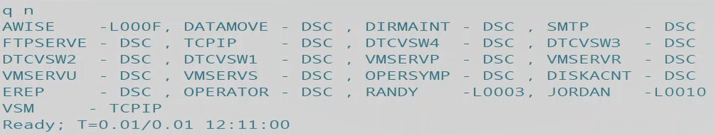
11. Once all Guests have been shut back down, log onto a privileged user able to submit commands to xautolog. Once logged in, submit xautolog commands for each Guest VM to be tested using a shell login.
    1. Xautolog name  
       Xautolog Mi99la40  
       
12. Confirm that all Guests are now present and xautologged successfully to a DSC disconnected state via Q N command.
    1. Query Name  
       q n  
       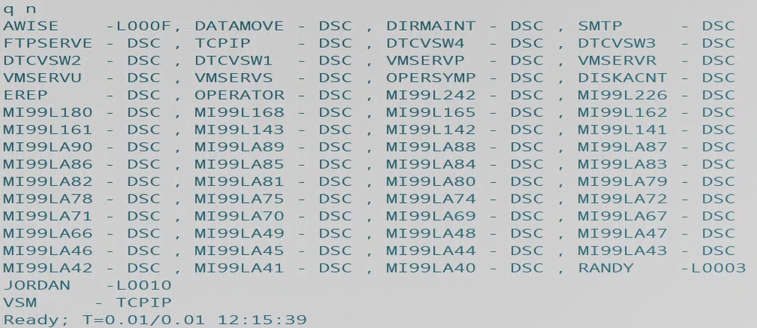
13. Once all Guests have been successfully Xautologged – test the ability to log into them via Shell (PuTTY for example.)

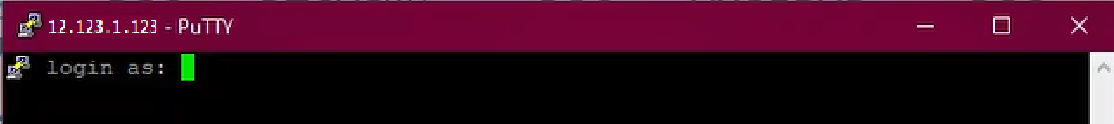

1. If you are able to successfully reach the login and command line within each guest machine, they are function and the upgrade/migration was a success!

Server Backups Log

|  |  |  |  |  |  |  |  |  |  |
| --- | --- | --- | --- | --- | --- | --- | --- | --- | --- |
|  | DIRM on  Old Sys  complete | Signal  Shutdown | Linux  Server  Name |  | COPY_STD | COPY  Special | First boot | xautolog | ssh |
| 1 |  |  | Guestname |  | O |  |  |  |  |
| 2 |  |  | Guest |  | O |  |  |  |  |
| 3 |  |  | Guest |  | O |  |  |  |  |
| 4 |  |  | Guest |  | O |  |  |  |  |
| 5 |  |  | Guest |  | O |  |  |  |  |
| 6 |  |  | Guest |  | O |  |  |  |  |
| 7 |  |  | Guest |  | O |  |  |  |  |
| 8 |  |  | Guest |  | O |  |  |  |  |
| 9 |  |  | Guest |  | O |  |  |  |  |
| 10 |  |  | Guest |  | O |  |  |  |  |
| 11 |  |  | Guest |  | O |  |  |  |  |
| 12 |  |  | Guest |  | O |  |  |  |  |
| 13 |  |  | Guest |  | O |  |  |  |  |
| 14 |  |  | Guest |  | O |  |  |  |  |
| 15 |  |  | Guest |  | O |  |  |  |  |
| 16 |  |  | Guest |  | O |  |  |  |  |
| 17 |  |  | Guest |  | O |  |  |  |  |
| 18 |  |  | Guest |  | O |  |  |  |  |
| 19 |  |  | Guest |  | O |  |  |  |  |
| 20 |  |  | Guest |  | O |  |  |  |  |
| 21 |  |  | Guest |  | O |  |  |  |  |
| 22 |  |  | Guest |  | O |  |  |  |  |
| 23 |  |  | Guest |  | O |  |  |  |  |
| 24 |  |  | Guest |  | O |  |  |  |  |
| 25 |  |  | Guest |  | O |  |  |  |  |
| 26 |  |  | Guest |  | O |  |  |  |  |
| 27 |  |  | Guest |  | O |  |  |  |  |
| 28 |  |  | Guest |  | O |  |  |  |  |
| 29 |  |  | Guest |  | O |  |  |  |  |
| 30 |  |  | Guest |  | O |  |  |  |  |
| 31 |  |  | Guest |  | O |  |  |  |  |
| 32 |  |  | Guest |  | O |  |  |  |  |
| 33 |  |  | Guest |  | O |  |  |  |  |
| 34 |  |  | Guest |  | O |  |  |  |  |
| 35 |  |  | Guest |  | O |  |  |  |  |
| 36 |  |  | Guest |  | O |  |  |  |  |
| 37 |  |  | Guest |  | O |  |  |  |  |
| 38 |  |  | Guest |  | O |  |  |  |  |
| 39 |  |  | Guest |  | O |  |  |  |  |
| 40 |  |  | Guest |  | O |  |  |  |  |
| 41 |  |  | Guest |  | O |  |  |  |  |
| 42 |  |  | Guest |  | O |  |  |  |  |

Return

System Swap Procedure Log

|  |  |  |
| --- | --- | --- |
| Step 1 |  | Copy Linux servers following check list |
| Step 2 |  | Update System Config VSWITCH OSA addresses to match CV1RES addresses |
| Step 3 |  | Update ‘PROFILE TCPIP’ – HOME address (on TCPMAINT 198) |
| Step 4 |  | Login hmc –  Get integrated console open for source system Lpar CV1SYS under ‘Recovery’ option |
| Step 5 |  | Logon source system CV1RES as any SYSADMIN UserID - ‘SHUTDOWN SYSTEM CV1RES’ |
| Step 6 |  | After shutdown completes –  open ‘Load’ profile under ‘Recovery’ option for CV1SYS and change ‘Load address’ to 0702D  and continue with ‘Load’ |

Return

COPY_STD

/* REXX SCRIPT TO Copy LINUX MINIDISKS 0100, 0101 and 0300 */

/* to B100, B101 and B300 */

/* */

ADDRESS COMMAND

"CP FLASHCOPY 0100 0 END TO B100 0 END "

IF RC <> 0 THEN DO

SAY 'CLONE OF VDev 0100 FAILED, RETURN CODE=' RC

EXIT

END

SAY 'CLONE OF 0100 COMPLETED SUCCESSFULLY!'

SAY ' '

"CP FLASHCOPY 0101 0 END TO B101 0 END "

IF RC <> 0 THEN DO

SAY 'CLONE OF VDev 0101 FAILED, RETURN CODE=' RC

EXIT

END

SAY 'CLONE OF 0101 COMPLETED SUCCESSFULLY!'

SAY ' starting copy of apps-vg MDISK 0300 '

"CP FLASHCOPY 0300 0 END TO B300 0 END "

IF RC <> 0 THEN DO

SAY 'CLONE OF VDev 0300 FAILED, RETURN CODE=' RC

EXIT

END

SAY 'CLONE OF 0300 COMPLETED SUCCESSFULLY!'

SAY ' '

EXIT

Return

COPY_B01

/* REXX SCRIPT - flashcopy MDISKS 0100, 0101, 0300 & 0301 */

/* to B100, B101, B300 & B301 */

/* */

ADDRESS COMMAND

"CP FLASHCOPY 0100 0 END TO B100 0 END "

IF RC <> 0 THEN DO

SAY 'CLONE OF VDev 0100 FAILED, RETURN CODE=' RC

EXIT

END

SAY 'CLONE OF 0100 COMPLETED SUCCESSFULLY!'

SAY ' '

"CP FLASHCOPY 0101 0 END TO B101 0 END "

IF RC <> 0 THEN DO

SAY 'CLONE OF VDev 0101 FAILED, RETURN CODE=' RC

EXIT

END

SAY 'CLONE OF 0101 COMPLETED SUCCESSFULLY!'

SAY ' starting copy of apps-vg MDISK 0300 '

"CP FLASHCOPY 0300 0 END TO B300 0 END "

IF RC <> 0 THEN DO

SAY 'CLONE OF VDev 0300 FAILED, RETURN CODE=' RC

EXIT

END

SAY 'CLONE OF 0300 COMPLETED SUCCESSFULLY!'

SAY ' '

SAY ' starting copy of apps-vg MDISK 0301 '

"CP FLASHCOPY 0301 0 END TO B301 0 END "

IF RC <> 0 THEN DO

SAY 'CLONE OF VDev 0301 FAILED, RETURN CODE=' RC

EXIT

END

SAY 'CLONE OF 0301 COMPLETED SUCCESSFULLY!'

SAY ' '

EXIT

Return

COPY_B03

/* REXX SCRIPT - flashcopy MDISKS 0100, 0101, 0300 & 0303 */

/* to B100, B101, B300 & B303 */

/* */

ADDRESS COMMAND

"CP FLASHCOPY 0100 0 END TO B100 0 END "

IF RC <> 0 THEN DO

SAY 'CLONE OF VDev 0100 FAILED, RETURN CODE=' RC

EXIT

END

SAY 'CLONE OF 0100 COMPLETED SUCCESSFULLY!'

SAY ' '

"CP FLASHCOPY 0101 0 END TO B101 0 END "

IF RC <> 0 THEN DO

SAY 'CLONE OF VDev 0101 FAILED, RETURN CODE=' RC

EXIT

END

SAY 'CLONE OF 0101 COMPLETED SUCCESSFULLY!'

SAY ' starting copy of apps-vg MDISK 0300 '

"CP FLASHCOPY 0300 0 END TO B300 0 END "

IF RC <> 0 THEN DO

SAY 'CLONE OF VDev 0300 FAILED, RETURN CODE=' RC

EXIT

END

SAY 'CLONE OF 0300 COMPLETED SUCCESSFULLY!'

SAY ' '

SAY ' starting copy of apps-vg MDISK 0303 '

"CP FLASHCOPY 0303 0 END TO B303 0 END "

IF RC <> 0 THEN DO

SAY 'CLONE OF VDev 0303 FAILED, RETURN CODE=' RC

EXIT

END

SAY 'CLONE OF 0303 COMPLETED SUCCESSFULLY!'

SAY ' '

EXIT

Return

COPYOS

/* REXX SCRIPT TO Copy LINUX MINIDISKS 0100 and 0101 */

/* to B100 and B101 */

/* TARGET MINIDISKS added to Linux servers */

/* */

/* note 'CP Commands' doc suggests extents must match - watch /apps */

/* - and - */

/* Guest FLASHCOPY support is restricted to dedicated */

/* or fullpack minidisks. */

/* */

ADDRESS COMMAND

"CP FLASHCOPY 0100 0 END TO B100 0 END "

IF RC <> 0 THEN DO

SAY 'CLONE OF VDev 0100 FAILED, RETURN CODE=' RC

EXIT

END

SAY 'CLONE OF 0100 COMPLETED SUCCESSFULLY!'

SAY ' '

"CP FLASHCOPY 0101 0 END TO B101 0 END "

IF RC <> 0 THEN DO

SAY 'CLONE OF VDev 0101 FAILED, RETURN CODE=' RC

EXIT

END

SAY 'CLONE OF 0101 COMPLETED SUCCESSFULLY!'

EXIT

Return